
VILNIUS GEDIMINas Technical university
Faculty of Electronics
department of Electrnics systems

Machine Learning
Practical work 1
Authors: Kirill Postrehan, EDIfu 24/1
Lecturer: Dr. Olusola Oluwakemi Abayomi Alli

VILNIUS 2026
Introduction:
During this laboratory work I have chosen to scrape two websites:
- https://books.toscrape.com/
- https://www.kaggle.com/datasets?tags=12107-Computer+Science
For the purpose of scraping the data from these two websites I used Selenium. Therefore you should have ChromeDriver beforehand.

Data source description:
The first website is a book “store” that list various books, showing their rating and prices. The second website is a huge and popular place to publish and download models and datasets, moreover here you can participate on forum discussions .

Analysis & visualizations:
From the first websited I scraped books cards and parsed them for their titltes, ratings and prices.
Got the numerical part of prices and ratings, consequently adding more columns the the pandas DataFrame instance of books; found the mean, median, mode and standart deviation.
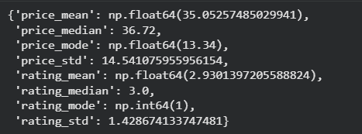
After that I presented the data by plotting 3 charts of 3 types: boxplot, bar and scatter.
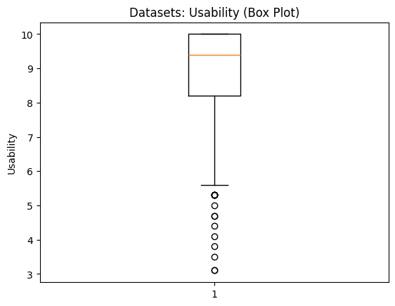
(picture 1 Usability Box Plot)
The orange line at 9.4 on the plot represents the median usbility score. It means that half of usabilities is above it and other half is underneath. The box that is displayed on the plot tells us that middle 50% of data is inside of it. The thin lines extending from the box points to lowest non-outlier value at around 5.6. Everything below is outside of normal range.

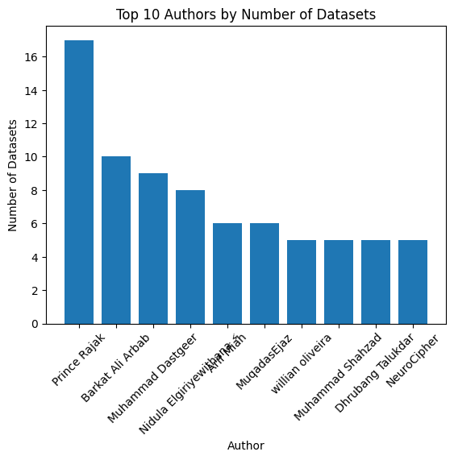
(picture 2. Top 10 authors)
The bar chart tells us that the majority of Computer Science datasets is authored by Prince Rajak showing a huge difference to others.
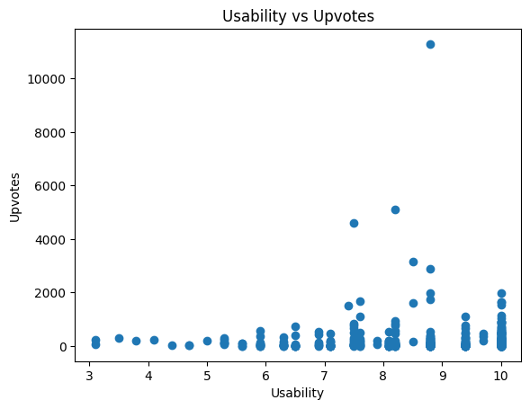
(picture 3. Usability vs Upvotes)
On this scatter plot we can just notice increase of upvotes as the usability rises. It shows an exceptionally high upvotes for some datasets that surpass 4000 and even 10000 upvotes.

Speaking of Kaggle i scraped datasets cards and retrieved their titles, authors, usabilities and number of upvotes. Then I found the length of each dataset’s title and added it to the DataFrame. As was required by the task I found mean, median, mode and standart deviation for the length of titles and datasets’ usabilities.
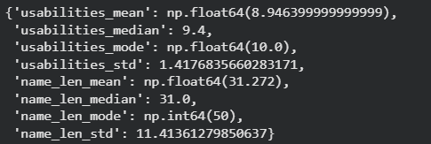

And got the following charts:
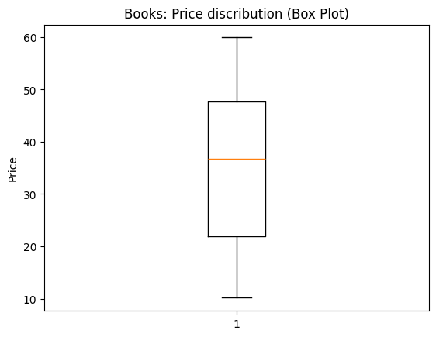
(Picture 4. Price distribution)
The orange line at 37 on the plot represents the median usbility score. It means that half of usabilities is above it and other half is underneath. The box that is displayed on the plot tells us that middle 50% of data is inside of it. The thin lines extending from the box points to lowest and highest non-outlier value at 10 and 60, respectively.

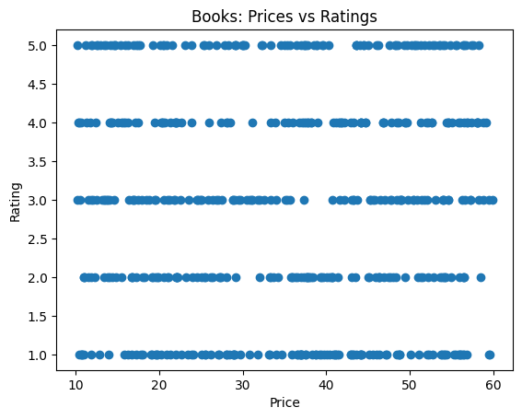
(picture 5. Prices vs Ratings)
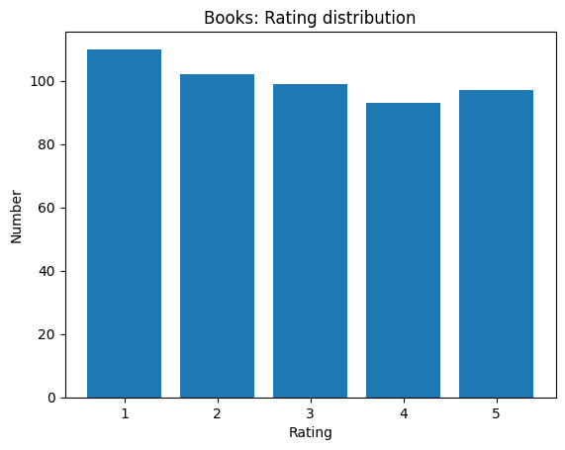
(picture 6. Rating distribution)
The bar chart shows that there are more low and mid rated books than rated with 4 or 5 stars.

Conclusion:
This bar chart shows that bad ratings lead better ones.
In this pratical work, data was scraped from two websites using Selenium and analyzed with pandas. After cleaning and converting the data to numerical form, measures like mean, median, mode, standard deviation were calculated and visualized using box plots, bar charts, and scatter plots.
The analysis revealed the distribution of book prices and ratings, as well as usability and upvote trends in Kaggle datasets. During the lab I demonstrated practical skills in web scraping, data preprocessing, and data visualization.

